Multiple files uploaded – Edit job

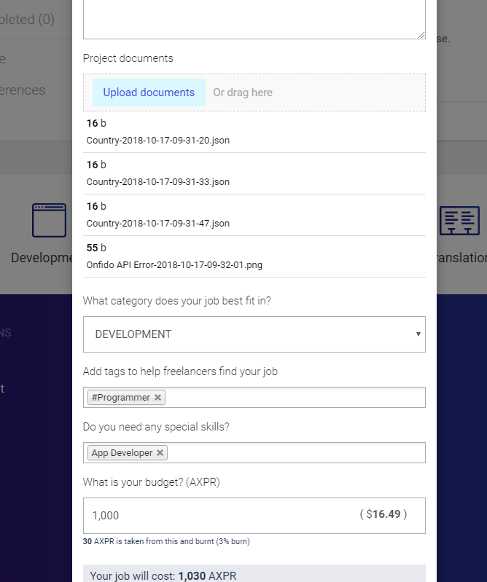

Popup overlay missing

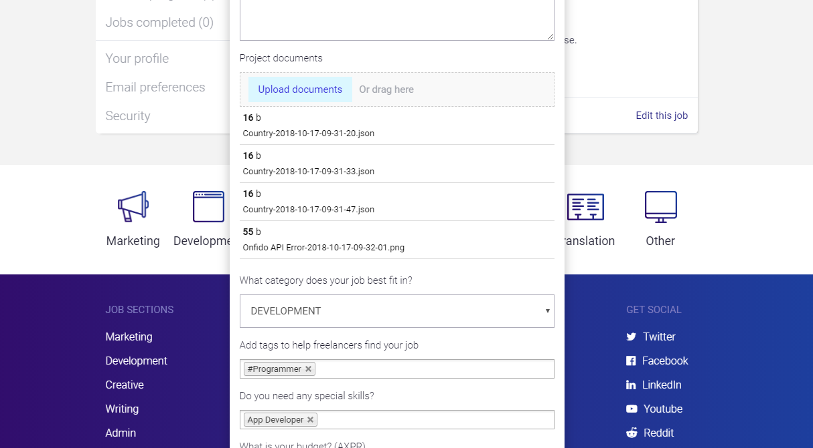

Bio not updating on first click

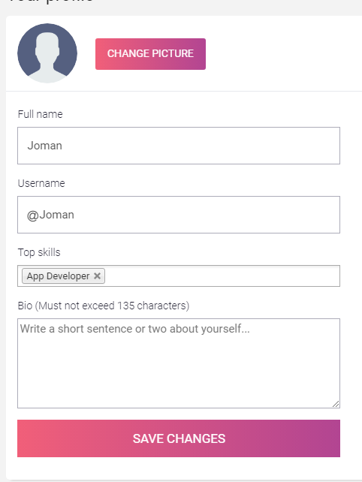

Wallet balance not showing – will show if click on it

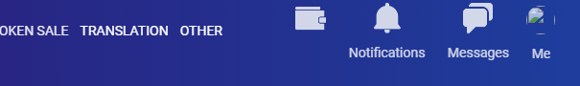

Message notification dot not hiding if message read



‘’No, cancel offer’’ – text is ok or not?

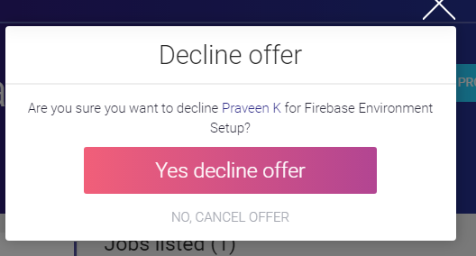

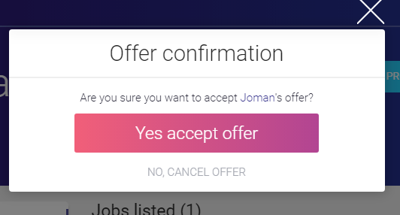

Multiple message for uncompleted accept offer

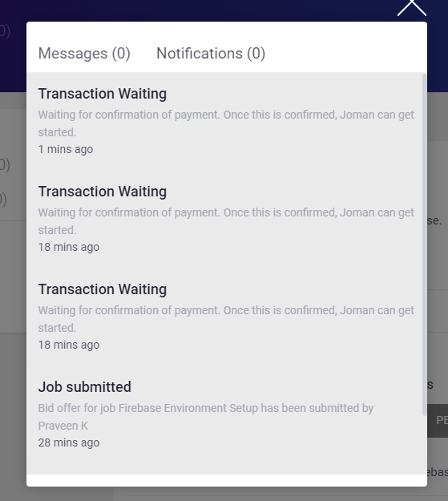

Can bid on already accepted job but pending transaction

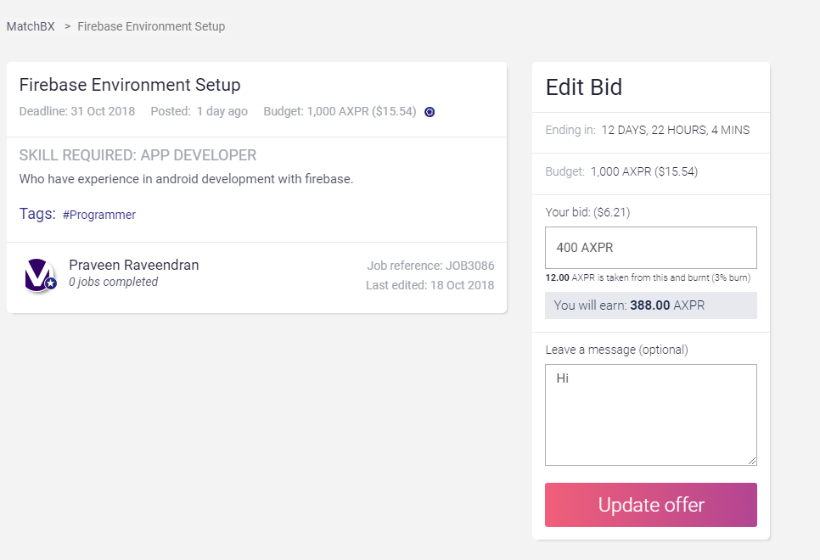

Alignment not correct

